### ****Case Study: Water Waste Management in Environmental Management****

#### ****Introduction****

Water waste management plays a crucial role in environmental sustainability by ensuring the efficient use, treatment, and recycling of wastewater. This case study explores a stepwise process of wastewater management with an architectural diagram to illustrate the system.

**Stepwise Process of Water Waste Management**

**Step 1: Collection of Wastewater**

* Wastewater is collected from various sources such as households, industries, and commercial buildings.
* It is transported through sewer networks and drainage systems to treatment plants.

**Step 2: Screening and Pre-Treatment**

* Large debris, such as plastic, leaves, and other solid waste, is removed using bar screens and grit chambers.
* This step prevents damage to pumps and machinery in the treatment plant.

**Step 3: Primary Treatment (Sedimentation)**

* The wastewater is allowed to settle in large tanks.
* Heavy particles (sludge) settle at the bottom, while oils and grease float on the surface and are removed separately.

**Step 4: Secondary Treatment (Biological Treatment)**

* Microorganisms break down organic matter in the wastewater.
* Techniques such as activated sludge processes, trickling filters, or bio-towers are used.
* This step significantly reduces the organic pollutants in the water.

**Step 5: Tertiary Treatment (Advanced Treatment)**

* Chemical and physical processes are applied to remove remaining contaminants.
* Processes such as filtration, chlorination, and UV treatment ensure the water is safe for reuse or release into natural water bodies.

**Step 6: Sludge Treatment and Disposal**

* The sludge collected from the primary and secondary treatment stages is processed further.
* It undergoes anaerobic digestion to produce biogas, which can be used for energy.
* Treated sludge can be used as fertilizers or safely disposed of.

**Step 7: Reuse and Recycling**

* Treated water is either reused for agricultural irrigation, industrial cooling, or groundwater recharge.
* Some of it may be released into rivers or lakes, maintaining environmental balance.

### ****Architectural Diagram of Water Waste Management System****

Below is a conceptual representation of the water waste management process:

+--------------------+

| Wastewater Source |

+--------+----------+

|

v

+-------------------+

| Screening & Grit | <-- Removes large debris

+-------------------+

|

v

+------------------+

| Primary Treatment| <-- Sedimentation process

+------------------+

|

v

+------------------+

| Secondary | <-- Biological treatment

| Treatment |

+------------------+

|

v

+------------------+

| Tertiary | <-- Filtration & chemical treatment

| Treatment |

+------------------+

|

v

+------------------+

| Reuse or Safe | <-- Recycled for irrigation, industrial use, etc.

| Disposal |

+------------------+

### ****Conclusion****

This stepwise approach to wastewater management ensures sustainable use of water resources while protecting the environment. The reuse of treated water in agriculture and industry reduces dependency on freshwater sources, promoting long-term water conservation

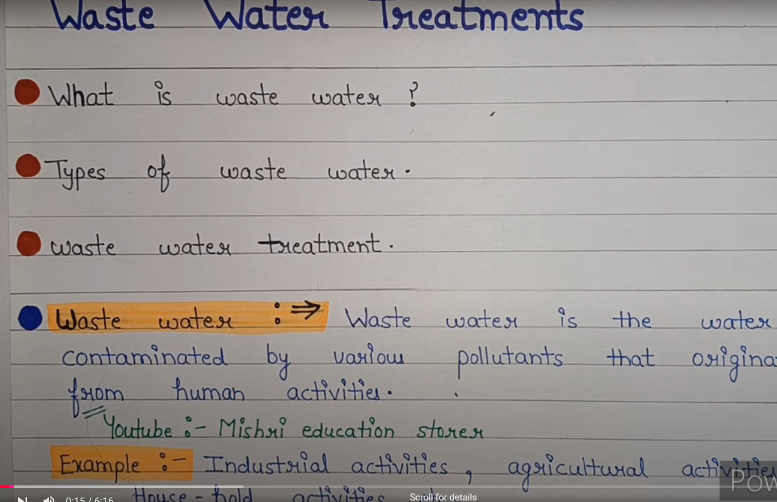

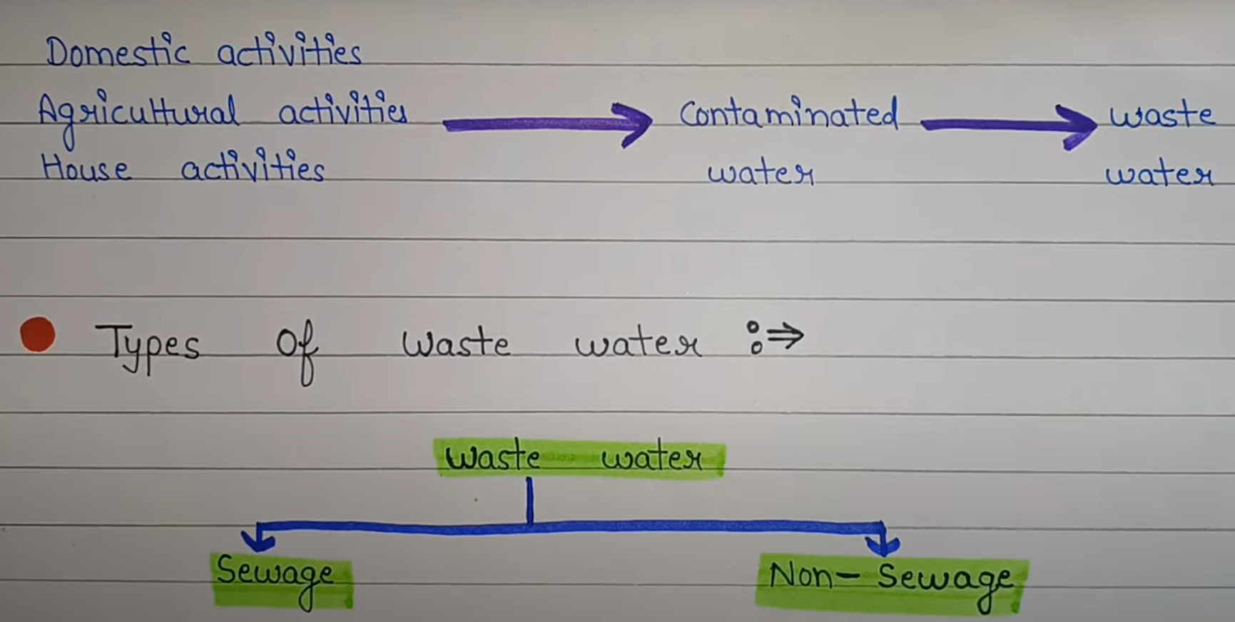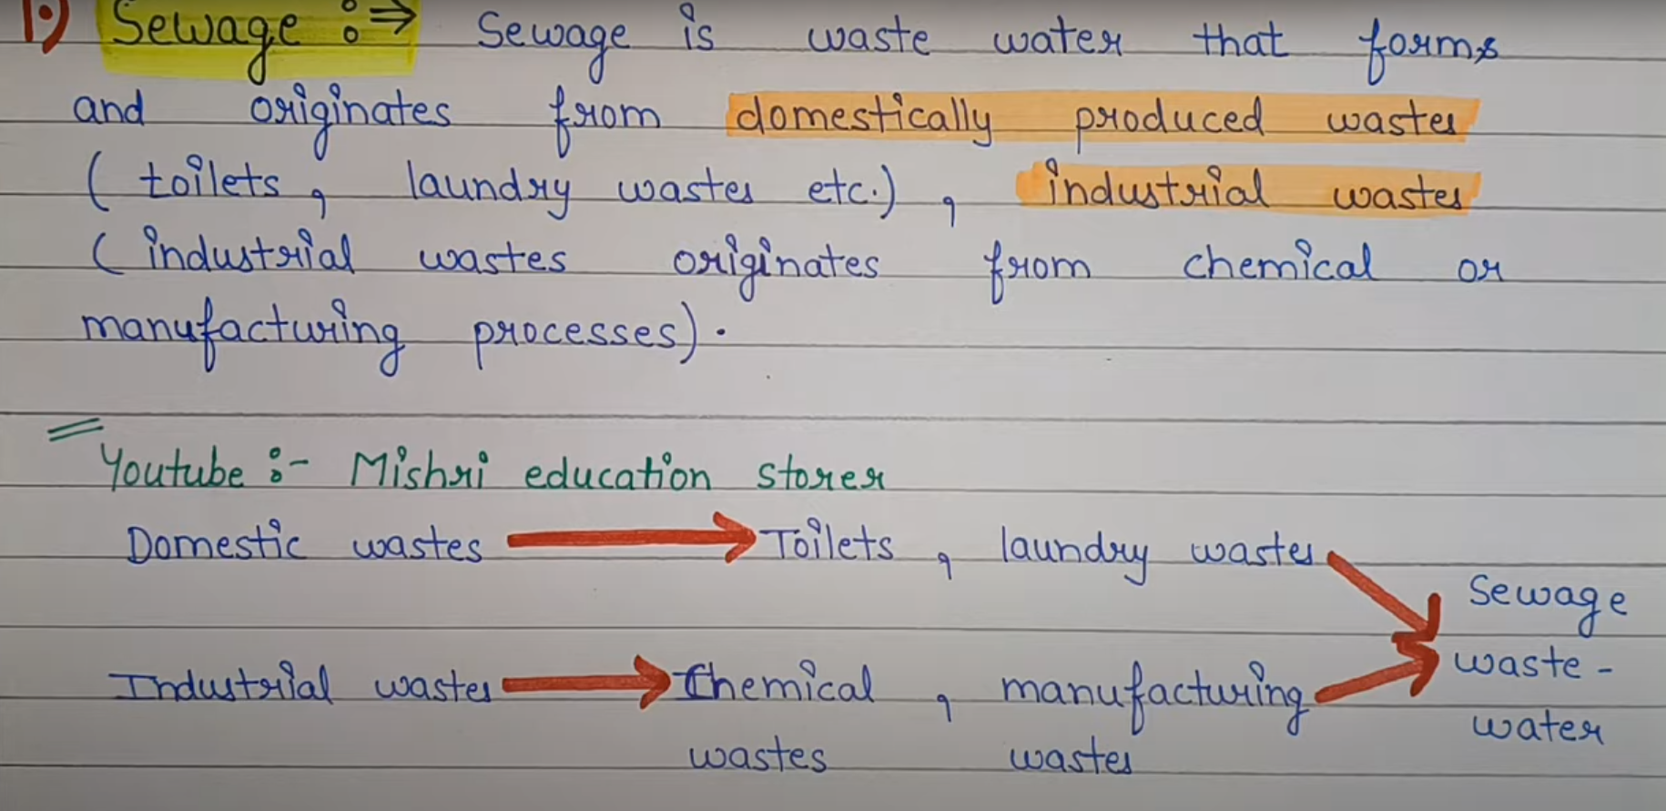 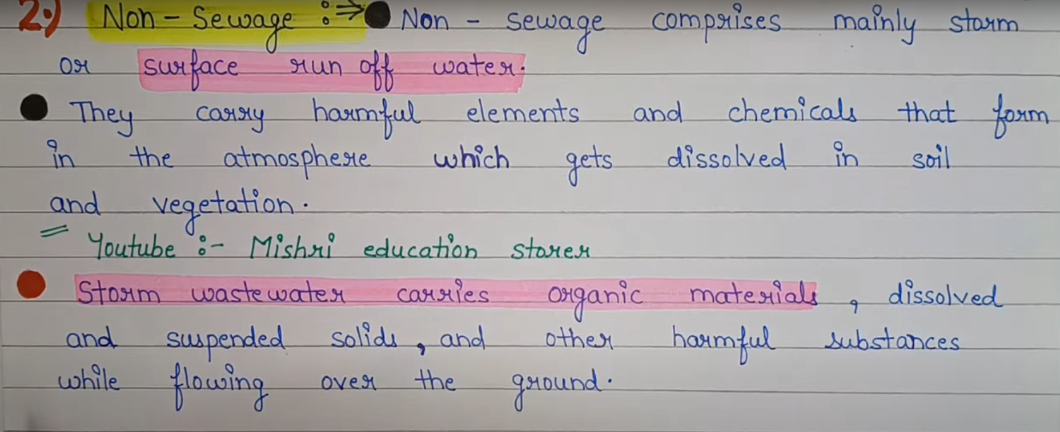

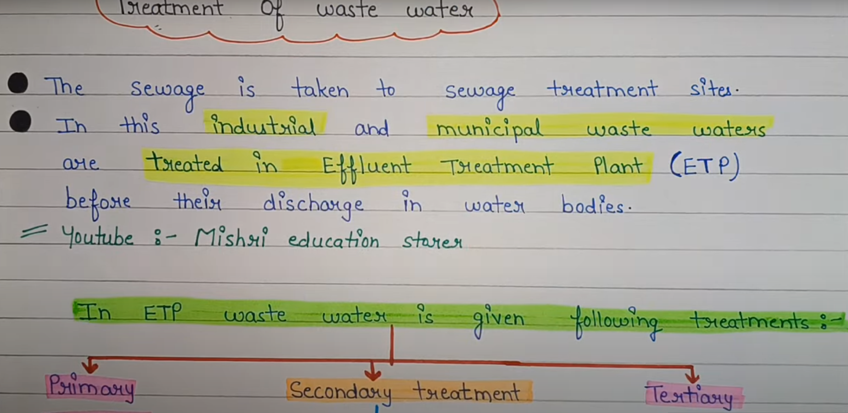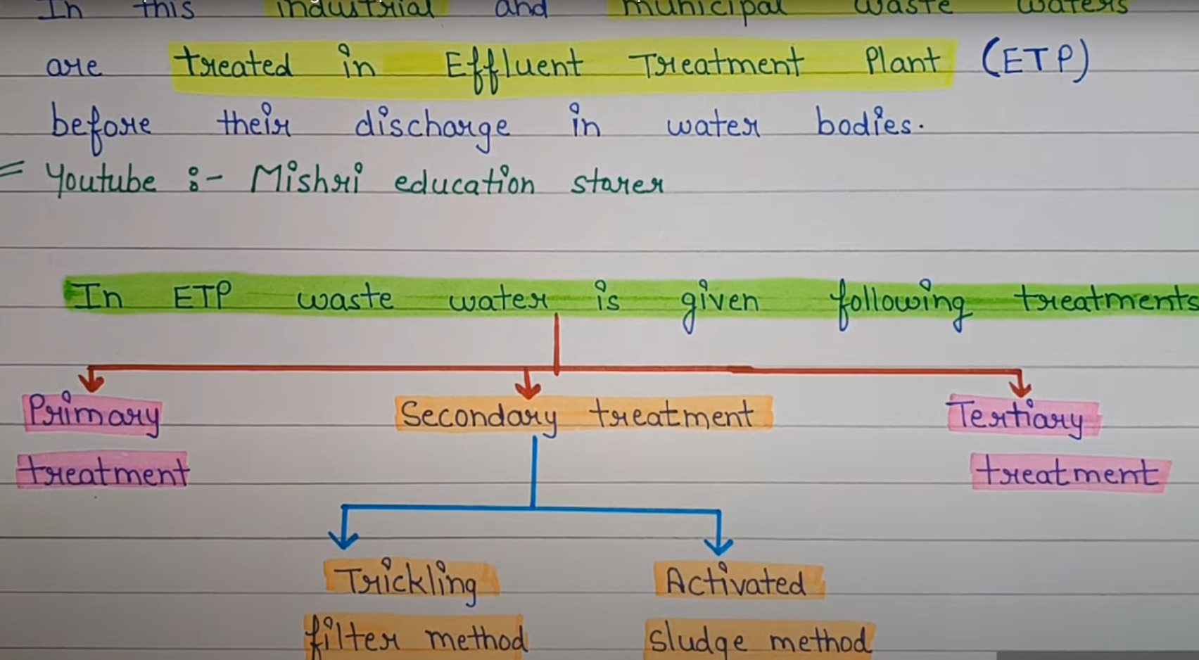

**Effluent water treatment** refers to the process of treating wastewater (effluent) from industries, factories, sewage plants, and other sources before it is discharged into the environment or reused. The primary goal is to **remove contaminants, pollutants, and harmful chemicals** to ensure the treated water meets environmental safety standards.

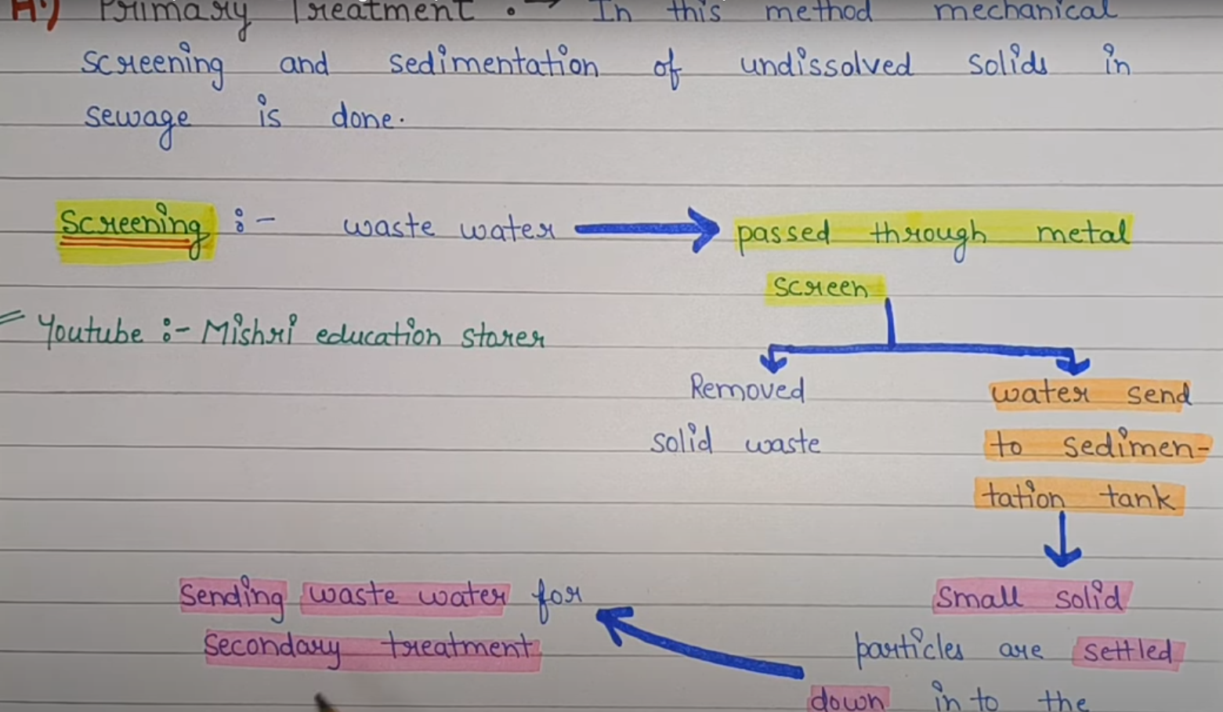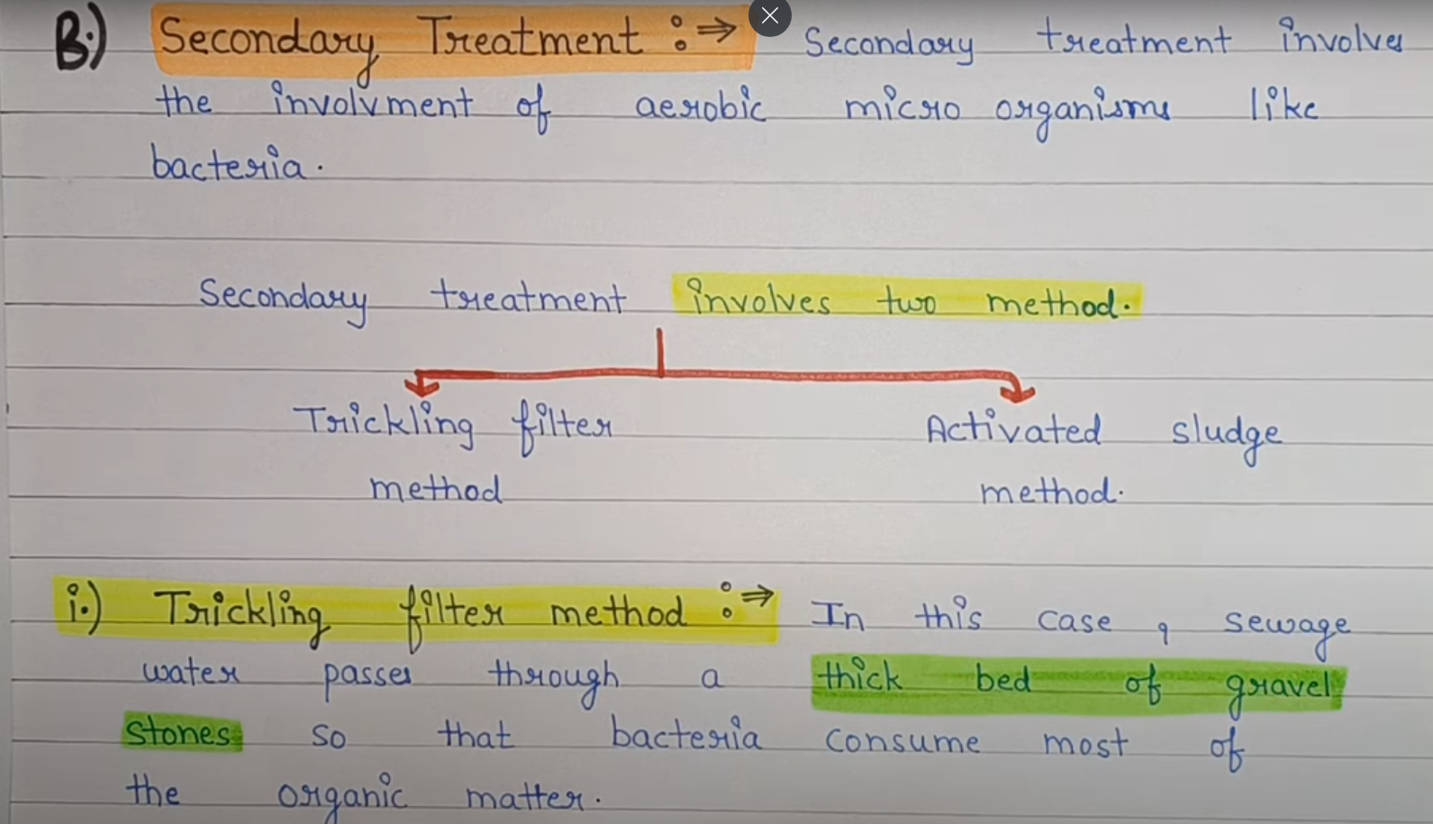

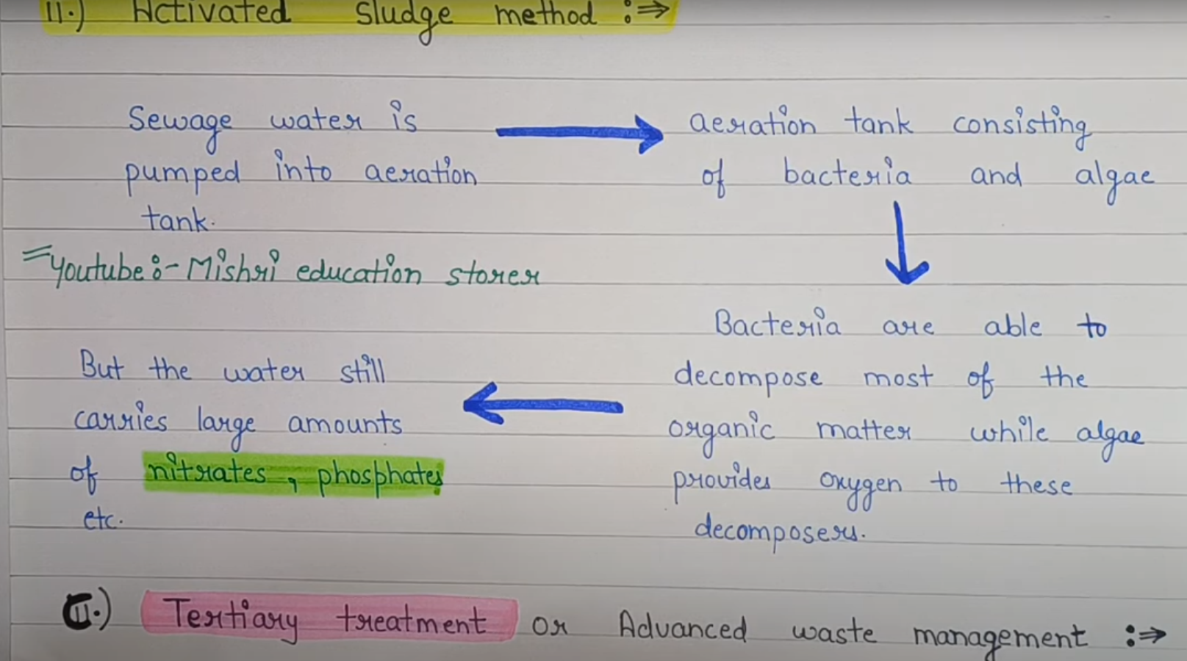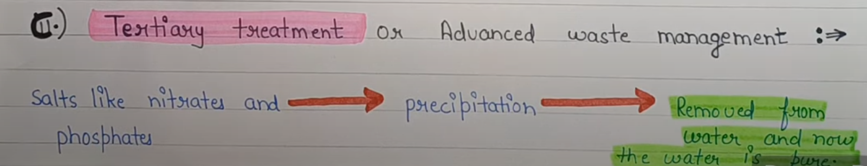

**Aeration** is the process of **introducing air (oxygen) into a liquid or substance**, commonly used in **water treatment, soil management, and industrial processes** to improve quality and remove impurities.

# **Case Study: Environmental Management of Air Pollution Using IoT and Machine Learning**

## **Introduction**

Air pollution is a critical environmental issue affecting public health and climate. Managing air pollution effectively requires **real-time monitoring, predictive analysis, and proactive control measures**. This case study explores an **IoT & Machine Learning-based Air Quality Management System** to monitor, predict, and mitigate air pollution levels.

## **Project Overview**

### ****Objective****

* **Real-time Air Quality Monitoring** using IoT sensors.
* **Data Analysis & Prediction** using Machine Learning.
* **Automated Alerts & Recommendations** for pollution control.
* **Integration with Smart City Infrastructure** for decision-making.

### ****Technology Stack****

* **IoT Sensors:** Air quality sensors (PM2.5, CO2, NO2, SO2).
* **Cloud Storage:** AWS/GCP for storing sensor data.
* **Machine Learning Model:** Predicts pollution trends.
* **Dashboard:** Web & Mobile interface using React/Angular.
* **Alert System:** SMS & Email notifications.

## **Stepwise Implementation of Air Pollution Management System**

### ****Step 1: Data Collection Using IoT Sensors****

📍 **Process:**

* Deploy **IoT-based air quality sensors** in urban areas.
* Sensors detect **PM2.5, CO, NO2, SO2, O3 levels** in real-time.
* Data is transmitted via **Wi-Fi/LTE to the cloud**.

📌 **Tools & Technologies:**

* **Sensors:** SDS011 (PM2.5), MQ-135 (CO2, NO2), NDIR (SO2).
* **Microcontrollers:** Arduino, Raspberry Pi.
* **Communication Protocols:** MQTT, HTTP, LoRaWAN.

### ****Step 2: Cloud Storage & Data Processing****

📍 **Process:**

* Raw data from IoT sensors is sent to a **cloud database** (AWS, Firebase).
* **Preprocessing & cleaning** of data to remove anomalies.
* Store data in **structured format** for real-time analysis.

📌 **Tools & Technologies:**

* **Cloud Storage:** AWS S3, Google BigQuery.
* **Data Processing:** Apache Kafka, Spark Streaming.

### ****Step 3: Air Pollution Prediction Using Machine Learning****

📍 **Process:**

* Train a **ML model** to predict pollution levels based on **historical data, weather, and traffic**.
* Use algorithms like **Random Forest, LSTM (Deep Learning)**.
* Deploy the model for **real-time inference**.

📌 **Tools & Technologies:**

* **ML Frameworks:** TensorFlow, Scikit-learn.
* **Data Analysis:** Pandas, NumPy, Matplotlib.
* **Deployment:** Flask API, FastAPI.

### ****Step 4: Real-time Dashboard for Visualization****

📍 **Process:**

* Design a **web dashboard** to display pollution levels **on maps**.
* Show **real-time air quality index (AQI)** & trends.
* Provide **heatmaps & pollution hotspots**.

📌 **Tools & Technologies:**

* **Frontend:** React, Angular.
* **Backend:** Node.js, Express.
* **Visualization:** D3.js, Plotly, Google Maps API.

### ****Step 5: Automated Alerts & Government Recommendations****

📍 **Process:**

* If pollution crosses a **threshold**, send alerts via **SMS, Email**.
* Recommend **traffic restrictions, industrial shutdowns, tree plantation**.
* Integrate with **municipal authorities** for emergency response.

📌 **Tools & Technologies:**

* **Notification System:** Twilio API, Firebase Cloud Messaging.
* **AI-based Recommendations:** Reinforcement Learning (RL).

## **System Architecture Diagram**

### ****📌 IoT-Based Air Pollution Management System Architecture****

sql

CopyEdit

+----------------+ +----------------+ +----------------+ +----------------+

| IoT Sensors | ---> | Edge Devices | ---> | Cloud Storage | ---> | ML Processing |

| (PM2.5, NO2) | | (Arduino, Pi) | | (AWS, Firebase)| | (LSTM, RF) |

+----------------+ +----------------+ +----------------+ +----------------+

|

v

+----------------+ +----------------+ +----------------+ +----------------+

| Real-time | ---> | Visualization | ---> | Alerts System | ---> | Govt Action |

| AQI Index | | (Web Dashboard)| | (SMS, Email) | | & Policies |

+----------------+ +----------------+ +----------------+ +----------------+

## **Results & Impact**

✔️ **Real-time tracking** reduced response time for pollution control.  
✔️ **Pollution forecasts helped authorities** implement preventive actions.  
✔️ **Automated alerts reduced health risks** for sensitive groups.  
✔️ **Integration with Smart Cities** improved urban air quality management.

## **Conclusion**

This **IoT & ML-based air pollution management system** enables **real-time monitoring, prediction, and decision-making** to reduce air pollution in cities. It is a scalable and efficient solution for **smart cities, environmental agencies, and governments**.

Would you like a **detailed code implementation** for any of these steps? 🚀

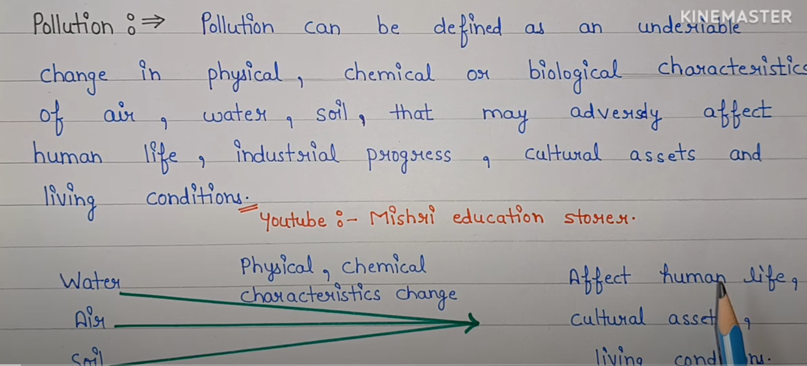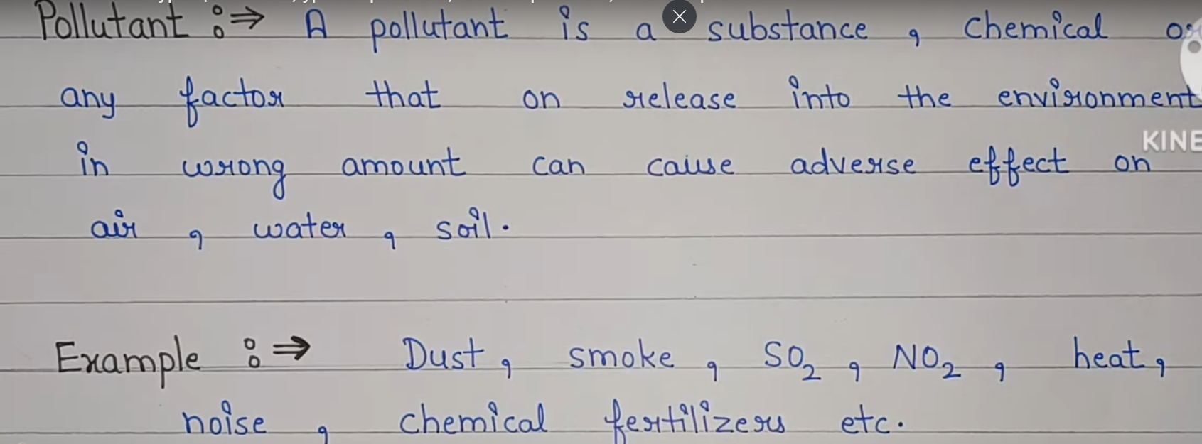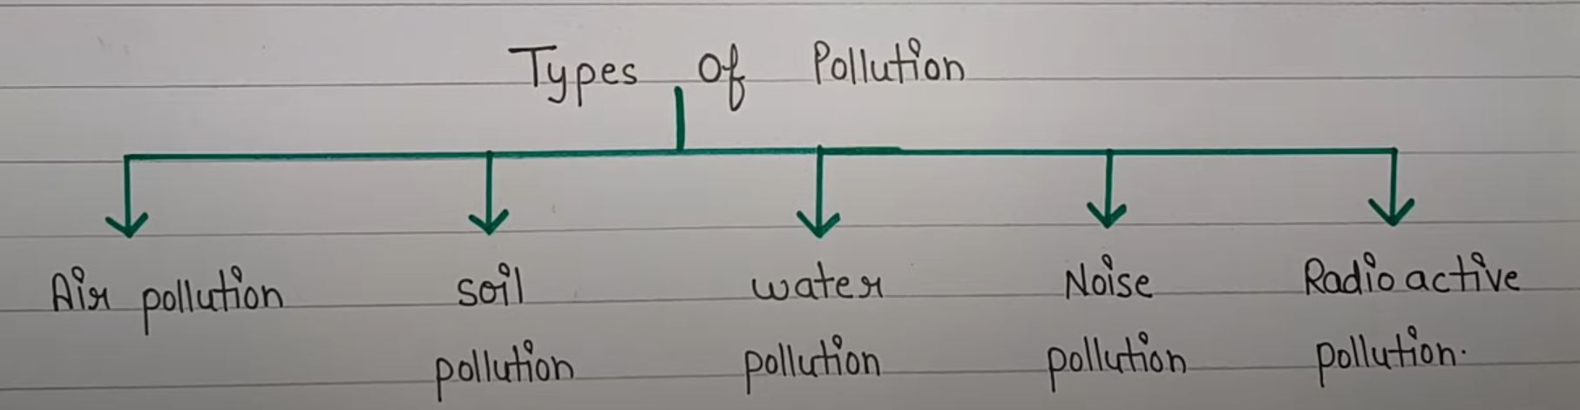

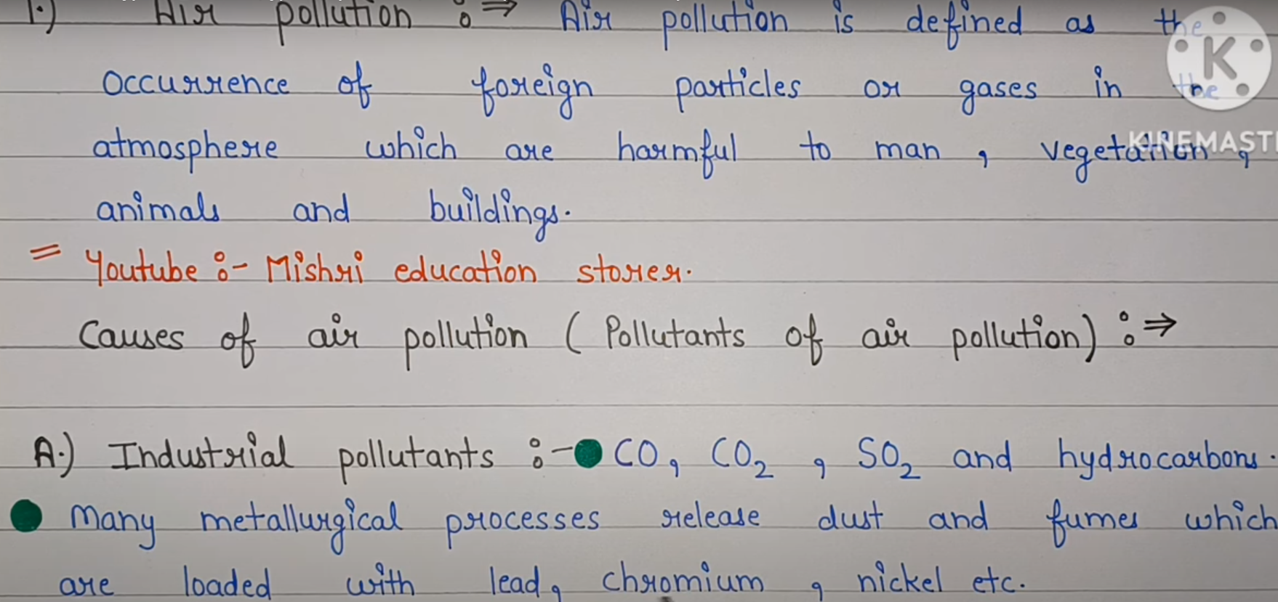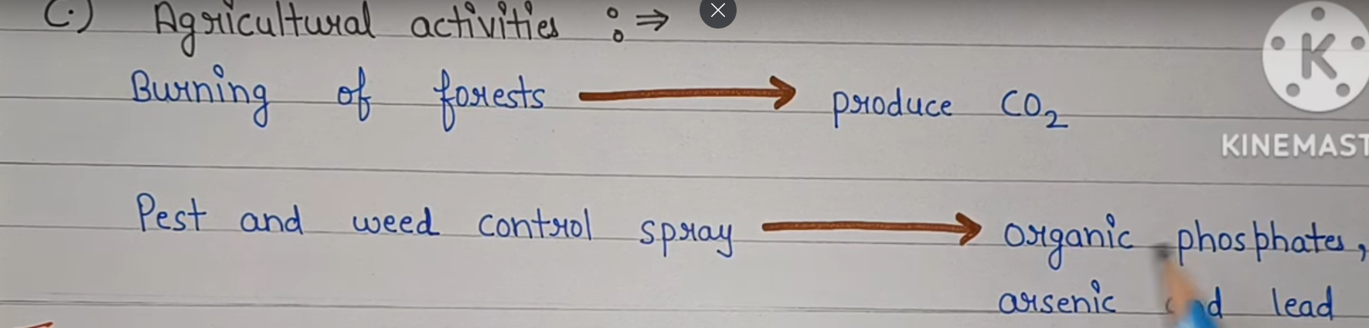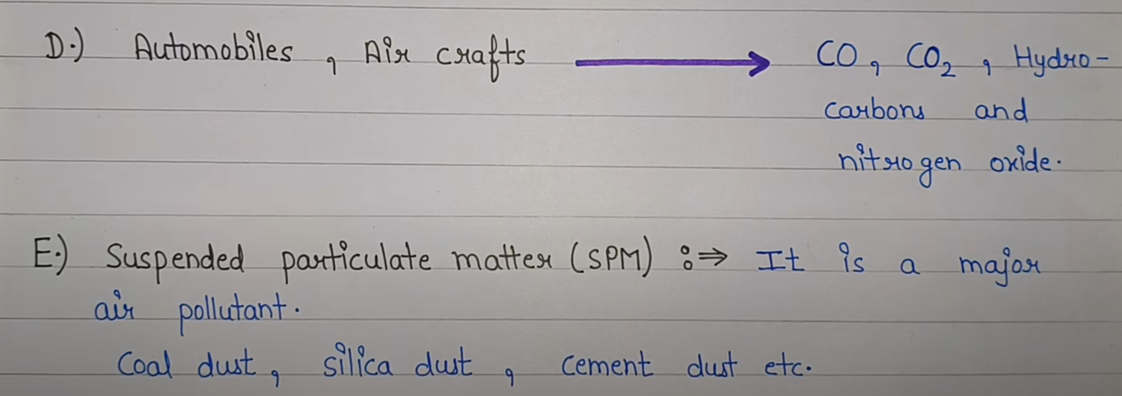

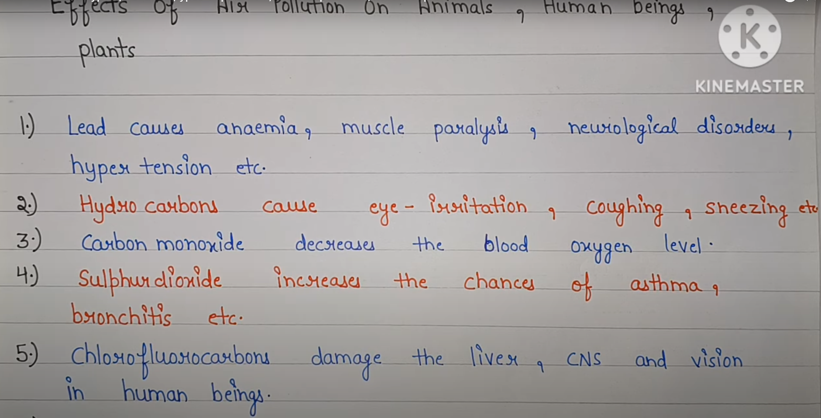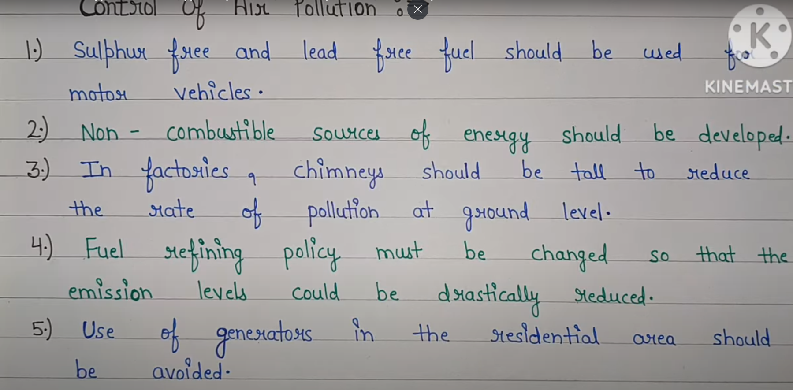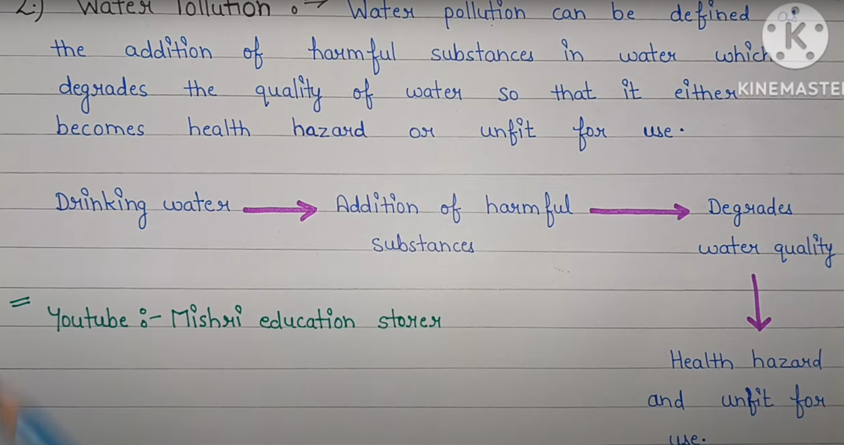

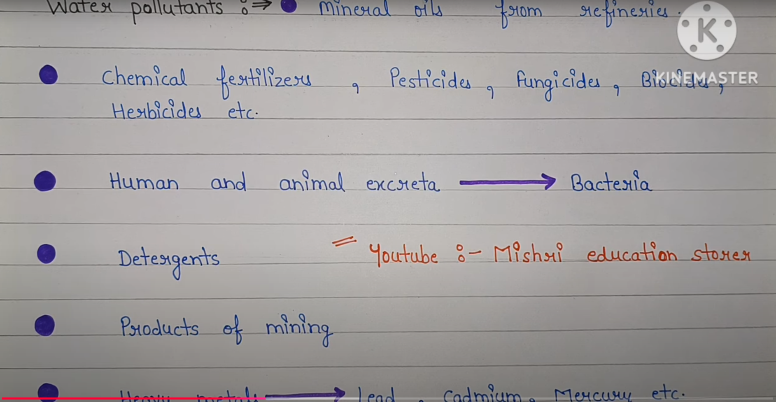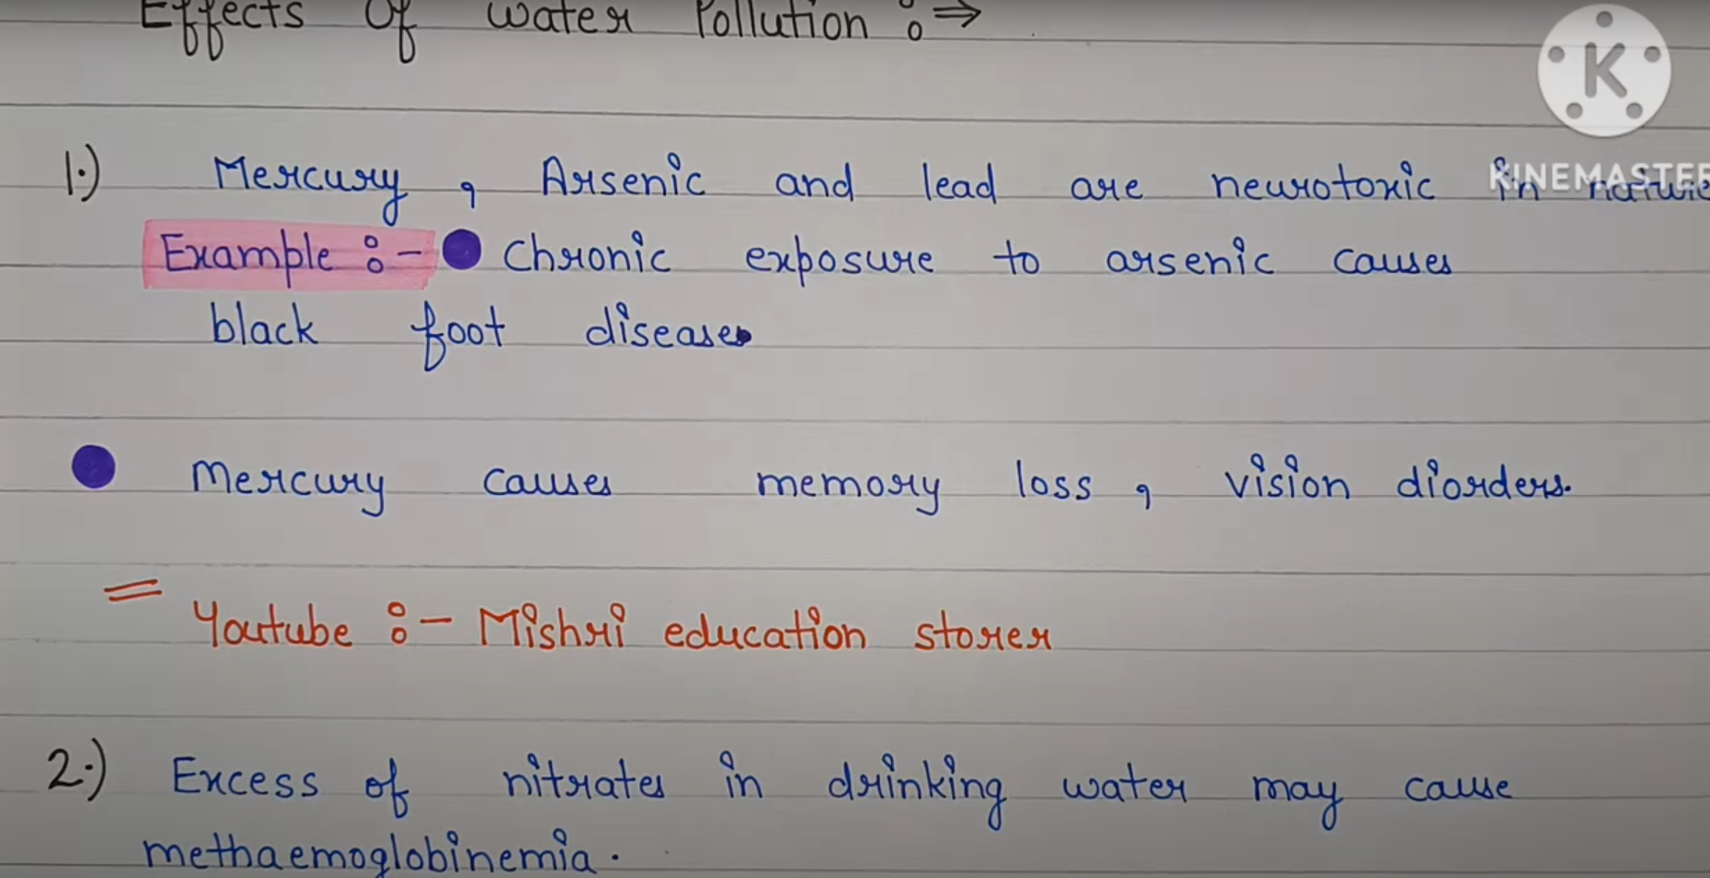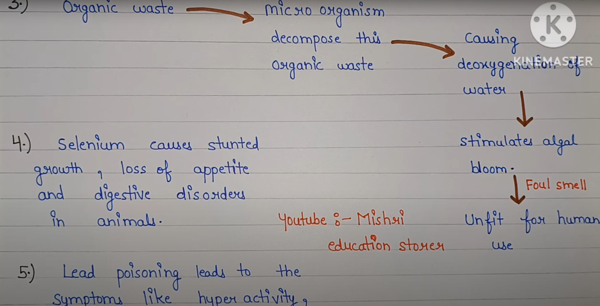

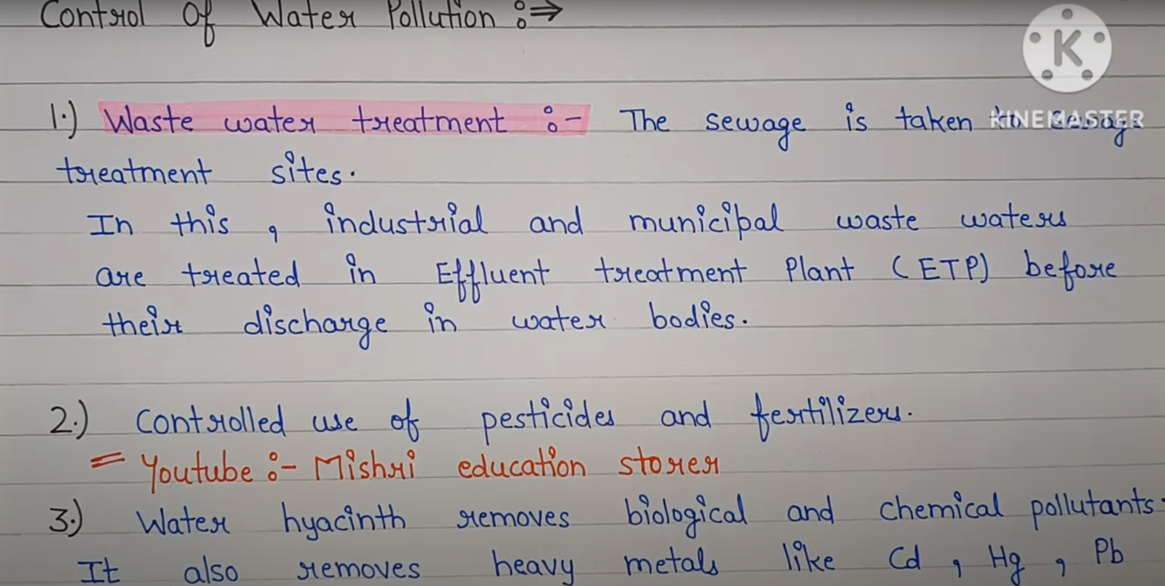

**Soil Pollution:**

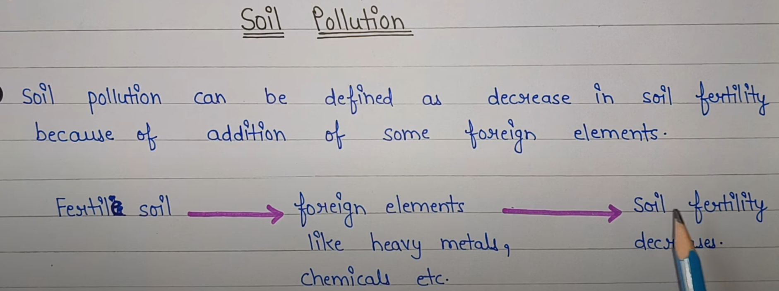

# **Case Study: Environmental Management of Overpopulation Using Smart Technologies**

## **Introduction**

Overpopulation leads to severe environmental challenges such as **deforestation, pollution, depletion of natural resources, and loss of biodiversity**. Managing overpopulation effectively requires **data-driven policies, smart urban planning, and sustainable resource management**. This case study explores how **AI, IoT, and GIS-based technologies** can help governments and organizations monitor and mitigate the environmental impact of overpopulation.

## **Project Overview**

### ****Objective****

* **Real-time Population Monitoring** using IoT & satellite data.
* **Urban & Resource Management** using AI-driven analytics.
* **Predictive Analysis** for sustainable city planning.
* **Policy Decision Support System** for effective governance.

### ****Technology Stack****

* **IoT & Sensors:** Smart cameras, traffic sensors.
* **Satellite Data:** GIS-based remote sensing.
* **Machine Learning:** Predictive modeling for population trends.
* **Cloud Computing:** Data storage and analysis.
* **Mobile & Web Apps:** Citizen engagement and awareness.

## **Stepwise Implementation of Overpopulation Management System**

### ****Step 1: Data Collection Using IoT & GIS****

📍 **Process:**

* Deploy **IoT sensors & CCTV cameras** in cities to track population density.
* Use **GIS & satellite imaging** to analyze land use and urban expansion.
* Collect **demographic data** from census, surveys, and government databases.

📌 **Tools & Technologies:**

* **IoT Devices:** Smart cameras, GPS trackers.
* **GIS Tools:** Google Earth Engine, ArcGIS.
* **Data Sources:** UN Population Database, Census Data.

### ****Step 2: Cloud Storage & Big Data Processing****

📍 **Process:**

* Store collected data in a **cloud-based data warehouse**.
* Use **Big Data frameworks** to process large datasets in real-time.
* Apply **AI-based filtering** to remove redundant data.

📌 **Tools & Technologies:**

* **Cloud Storage:** AWS, Google Cloud, Azure.
* **Big Data Processing:** Apache Spark, Hadoop.

### ****Step 3: AI & Machine Learning for Population Prediction****

📍 **Process:**

* Train **ML models** to predict population growth trends.
* Use **historical and real-time data** for forecasting.
* Implement **deep learning models** to analyze satellite images.

📌 **Tools & Technologies:**

* **ML Frameworks:** TensorFlow, Scikit-learn.
* **AI Algorithms:** Regression Models, LSTM for time-series forecasting.

### ****Step 4: Sustainable Urban & Resource Management****

📍 **Process:**

* Use **AI-based simulations** for city expansion planning.
* Optimize **water, food, and energy resource distribution**.
* Implement **traffic & waste management solutions** to reduce pollution.

📌 **Tools & Technologies:**

* **Urban Planning Software:** AutoCAD, QGIS.
* **Resource Optimization Tools:** IoT-based smart grids, smart water meters.

### ****Step 5: Policy Decision & Citizen Engagement****

📍 **Process:**

* Governments use AI-driven dashboards to **monitor overpopulation trends**.
* Implement **family planning awareness campaigns** through mobile apps.
* Launch **smart governance policies** for sustainable city growth.

📌 **Tools & Technologies:**

* **Decision Support Systems:** Power BI, Tableau.
* **Mobile Apps:** Citizen feedback & awareness programs.

## **System Architecture Diagram**

### ****📌 AI-Driven Overpopulation Management System Architecture****

lua

CopyEdit

+----------------+ +----------------+ +----------------+ +----------------+

| IoT Sensors | ---> | Cloud Storage | ---> | AI Prediction | ---> | Policy & Urban |

| (Cameras, GPS)| | (AWS, GCP) | | (ML Models) | | Planning |

+----------------+ +----------------+ +----------------+ +----------------+

|

v

+----------------+ +----------------+ +----------------+ +----------------+

| Citizen Apps | ---> | Govt Dashboards| ---> | Resource Mgmt | ---> | Awareness & |

| (Alerts, Tips)| | (Power BI) | | (AI-based) | | Planning |

+----------------+ +----------------+ +----------------+ +----------------+

## **Results & Impact**

✔️ **Predictive AI helped governments** allocate resources efficiently.  
✔️ **Smart city planning reduced congestion** in high-density areas.  
✔️ **IoT-based monitoring improved** waste and traffic management.  
✔️ **Citizen engagement increased awareness** about population control.

## **Conclusion**

This **AI & IoT-based overpopulation management system** enables **real-time monitoring, prediction, and decision-making** to reduce overpopulation’s impact on the environment. It provides **scalable and sustainable solutions** for governments, urban planners, and environmental agencies.

Would you like a **detailed implementation** of any step? 🚀

# **Case Study: Environmental Management of Overpopulation Using Latest Full-Stack Development**

## **Introduction**

Overpopulation is a significant environmental challenge, leading to **deforestation, pollution, resource depletion, and increased carbon emissions**. To tackle this issue, a **Full-Stack web application** can be developed using **modern technologies** to analyze population growth, predict trends, and provide solutions to policymakers.

## **Project Overview**

### ****Application Name:**** ****EcoPop (Overpopulation Management System)****

### ****Objective:****

* **Monitor and predict population growth** trends in different regions.
* **Analyze environmental impacts** caused by overpopulation.
* **Provide insights & policy recommendations** for sustainable planning.
* **Engage users with an interactive dashboard** for awareness and action.

### ****Technology Stack****

#### ****Frontend (User Interface)****

* **React.js (Next.js)** → For a responsive, fast, and interactive UI.
* **Tailwind CSS** → For modern and lightweight styling.

#### ****Backend (Business Logic & APIs)****

* **Node.js + Express.js** → To handle API requests and data processing.

#### ****Database (Storage & Querying)****

* **MongoDB Atlas** → A NoSQL cloud database for storing population and environmental data.

#### ****Other Integrations****

* **Machine Learning (Python - Flask/FastAPI)** → Predicts overpopulation impact.
* **Google Maps API** → Visual representation of affected regions.
* **Twilio API** → Sends SMS/email alerts on critical population data.
* **Cloud Hosting:** AWS EC2 / Firebase for deployment.

## **Stepwise Implementation of Overpopulation Management System**

### ****Step 1: Data Collection & Storage****

📍 **Process:**

* Gather **real-time population data** from government sources (Census, UN, WHO).
* Store data in a **MongoDB database** with structured records.

📌 **Tools & Technologies:**

* **APIs:** World Population API, Open Data Portal.
* **Database:** MongoDB (NoSQL) for fast querying.

### ****Step 2: Backend Development for Data Processing****

📍 **Process:**

* Create a **Node.js + Express.js API** to fetch population data.
* Develop an endpoint to **fetch, analyze, and update population trends**.

📌 **Tools & Technologies:**

* **Backend:** Node.js, Express.js.
* **Authentication:** JWT for secure access.
* **REST APIs:** /api/population (Fetch data), /api/trends (Analyze).

### ****Step 3: Machine Learning Model for Overpopulation Prediction****

📍 **Process:**

* Train a **ML model** to predict population trends using historical data.
* Use **LSTM (Long Short-Term Memory)** for accurate forecasting.
* Deploy the model with a **Flask/FastAPI** backend.

📌 **Tools & Technologies:**

* **ML Algorithms:** LSTM, Time Series Forecasting.
* **Libraries:** TensorFlow, Pandas, Scikit-learn.

### ****Step 4: Frontend Dashboard for Visualization****

📍 **Process:**

* Display **real-time population trends & environmental impact** on a web app.
* Show **heatmaps & graphs** for affected regions.
* Allow users to **filter data based on location, year, and demographics**.

📌 **Tools & Technologies:**

* **Frontend:** React.js, Next.js.
* **UI Framework:** Tailwind CSS, Chart.js.
* **Data Visualization:** Google Maps API, D3.js.

### ****Step 5: Alerts & Policy Recommendations System****

📍 **Process:**

* Send **alerts to policymakers & environmental agencies** about overpopulation risks.
* Suggest **sustainable solutions** such as urban planning, resource allocation, and migration control.

📌 **Tools & Technologies:**

* **Notifications:** Twilio API (SMS, Email).
* **AI-based recommendations:** Predictive models suggest policies.

## **System Architecture Diagram**

### ****📌 Full-Stack Overpopulation Management System Architecture****

scss

CopyEdit

+----------------+ +----------------+ +----------------+ +----------------+

| Data Sources | ---> | Backend APIs | ---> | Machine Learning| ---> | Visualization |

| (Census, WHO) | | (Node.js, Exp) | | (LSTM Model) | | (React, Maps) |

+----------------+ +----------------+ +----------------+ +----------------+

|

v

+----------------+ +----------------+ +----------------+ +----------------+

| Population | ---> | Heatmaps | ---> | Alerts System | ---> | Policy Impact |

| Growth Trends| | (Google Maps) | | (Twilio API) | | (Govt. Reports)|

+----------------+ +----------------+ +----------------+ +----------------+

## **Results & Impact**

✔️ **Real-time monitoring of population trends** for policy decisions.  
✔️ **Accurate forecasting** of environmental impact using AI.  
✔️ **Automated alerts** help authorities take proactive steps.  
✔️ **Engages users with interactive data visualizations**.

## **Conclusion**

This **Full-Stack solution for overpopulation management** provides **real-time monitoring, predictive insights, and data-driven policy recommendations**. It integrates **React, Node.js, MongoDB, and AI models** to create an **efficient, scalable, and interactive** system for environmental management.

Would you like **detailed code implementation** for any step?

*********************************************************************************